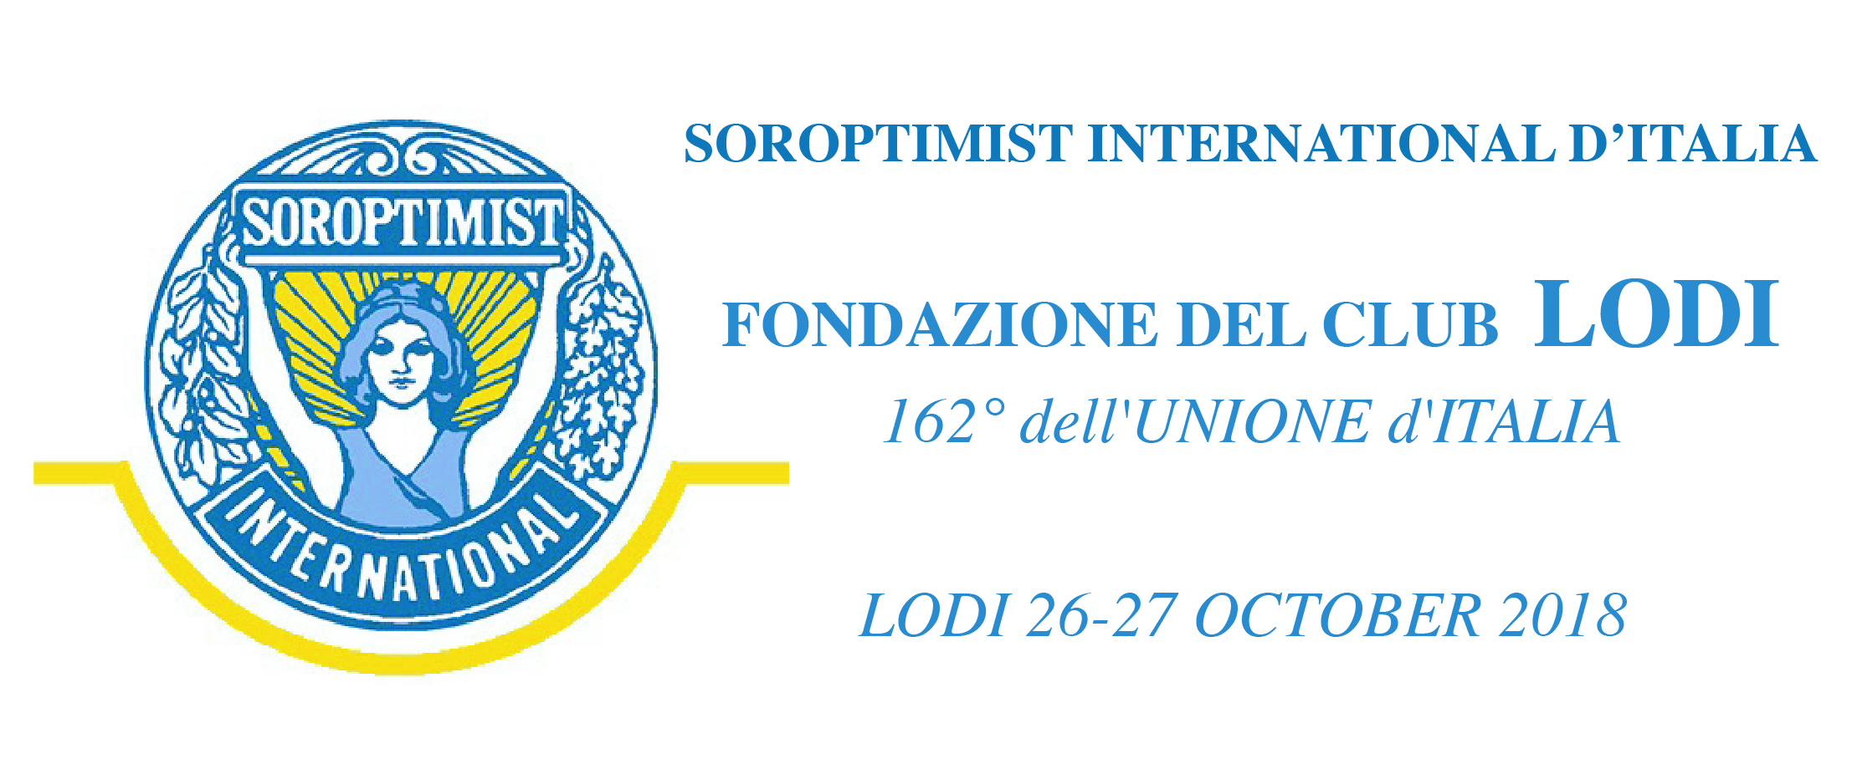

PARTICIPANT REGISTRATION FORM

LastNam…………………….……………. FirstName………………….………………………
Address……….………………………………………………………………..……………..
Membership Club / role ………..………………………………………………………………………………
Partner ….…………………………………………………………………..…………………………………………………
Email…………………………….……………………………….Telephone………………………..….……….

SUBSCRIPTION FEE.
- Welcome Dinner - Friday 26th October – Ristorante Gaffurio, Lodi

€ 30,00 - nr. of person…………. – Total €………………..
- Light Lunch Saturday 27th October – Ristorante Castello, Lodi

€ 25,00 - nr. of person…………. – Total €………………..
- Gala/Foundation Dinner Saturday 27th October – Ristorante La Coldana, Lodi

€ 55,00 - nr. of person…………. – Total €………………..

_________________________

Total bank transfer €………………..

HOTEL RESERVATION
ALBERGO ANELLI - Via Vignati, 7 - 26900 Lodi - Tel 0371 421354 - info@albergoanelli.com
Special Rate Soroptimist - B&B:
single room per night € 70,00
double room per night € 95,00

HOTEL CONCORDE - Piazzale Stazione 2 - 26900, Lodi - Tel 0371 421322 - lodi@hotel-concorde.it
Special Rate Soroptimist - B&B:
single room per night € 80,00
double room per night € 90,00

AGRITURISMO CAVRIGO - Cascina Cavrigo 35 – 26900 Lodi – tel 0371 432463 – info@agriturismocavrigo.it
Special Rate Soroptimist - B&B:
single room per night € 70,00
double room per night € 90,00

PLEASE CONTACT DIRECTLY THE HOTEL FOR RESERVATION AND PAYMENT asking for the special rate Soroptimist

HOW TO REACH US
By Train – Line Milano-Bologna – Stop at Lodi Station
By PLANE – Airports of Linate (35km), Malpensa (100km) – Orio al Serio (65km)

INFO
Secretariat of Soroptimist d’Italia Club di Lodi – Mrs. Alessandra Calcagno
e-mail: soroptimist.lo@gmail.com mob +39 335 1286378

BOOKING RESERVATION
Please send by e-mail, by 5th October 2018 this form filled out in all its parts, with attached copy of the bank transfer, to the secretariat of Lodi Club, and you will receive booking confirmation
PAYMENT
Bank Transfer to Soroptimist d’Italia Club di Lodi
IBAN: IT85H0832420301000000192006
Code: BIC/SWIFT: ICRAITRR900

I authorize the use of my personal data according to the Privacy Act (art.13 of D.Lgs 196/03)

Date………………………………….. Signature………………………………………..

ADRESSES:
- RISTORANTE GAFFURIO, V Gaffurio 11, Lodi
- FONDAZIONE MARIA COSWAY Piazza Zaninelli 13 , Lodi ( entrance from the ancient walls)
- RISTORANTE CASTELLO, Piazza Castello 2, Lodi
- RISTORANTE LA COLDANA, Cascina Coldana Via privata del Costino ,( ritrovo in Piazzale Medaglie D’Oro)
- FESTIVAL DELLA FOTOGRAFIA ETICA, per info: www.festivaldellafotografiaetica.it/dove-e-come

