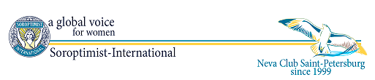

20th ANNIVERSARY CELEBRATION
REGISTRATION FORM

Please fill in the Registration Form and send it back to info@nordictravelrussia.com
Contact person: Luba Sofian
Tel. +7 (921) 934-83-94

First name (as in passport): | Last name (as in passport): | Date of Birth:
Passport Number | Citizenship: | E-mail address:
Accompanying persons

Please state your arrival and departure dates and flight details.
Check in dates: | Arrival flight details | Arrival transfer needed  YES / NO
Check out dates: | Departure flight details | Departure transfer needed  YES / NOW

Please specify the hotel

Hotel name | Room type
Helvetia Hotel
Cronwell Inn Stremyannaya Hotel

Optional tours

Pushkin (Tzar’s Village). Half-day tour including visit to Catherine Palace & park (5 h)
St. Isaac’s Cathedral Tour (2,5 h)
The Church of the Savior on the Spilled Blood Tour (2,5 h)
The Russian Museum Tour

After confirmation of your accommodation at a hotel, we will forward the Booking number and the Visa Support Letter to you.
We would appreciate it if the hotel accommodation will be paid via bank transfer.
Bank: | SBERBANK OF THE RUSSIAN FEDERATION (SEVERO-ZAPADNIY OFFICE)  ST.PETERSBURG, RUSSIA
Bank address: | Russia, St.Petersburg, V.O. , 17 liniya, 22
SWIFT: | SABRRU2P
FAVOR: | 40702978555200277161 (EURO)
On behalf of: | NORDIC TRAVEL
Bank fees and charges: | Paid by the payer
Details of Payment

