SOROPTIMIST INTERNATIONAL CLUB VARNA 20TH ANNIVERSARY
REGISTRATION FORM
Personal information
Name
Telephone
E-mail
City, Country
SI Club
If non-Soroptimist, how did you hear about us?

27 September 2019
Welcome party  Varna Restaurant |  | Will you attend?  Choose an item. |  | Menu  Choose an item. |  | 35 €
28 September 2019
Guided tour  The Beauty of North-East Bulgaria  - Evksinograd Palace  - Durankulak Archaeological Reserve  - Lunch at the Lake of Durankulak  - Kaliakra Cape |  | Will you attend?  Choose an item. | Lunch menu  Choose an item. |  |  | 65 €
Gala dinner  Galatea Ballroom, Rosslyn-Dimyat |  | Will you attend?  Choose an item. | Menu  Choose an item. |  |  | 45 €
29 September 2019
Guided tour  The Historical Heritage of Varna  - Museum of Archaeology  - Roman Thermae | Will you attend?  Choose an item. |  |  |  |  | 15 €
Lunch  Staria Chinar Restaurant, Varna Port | Will you attend?  Choose an item. |  |  | Menu  Choose an item. |  | 25 €

Accommodation options
Rosslyn-Dimyat | 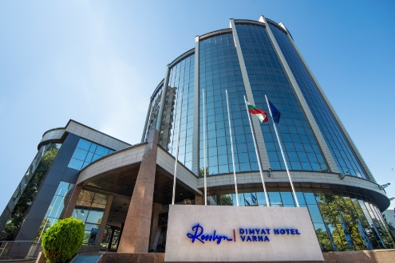 | Book here  Promo code: SOROPT280919  Discount: 12 %  Validity: 15 April – 26 September
Cherno more | 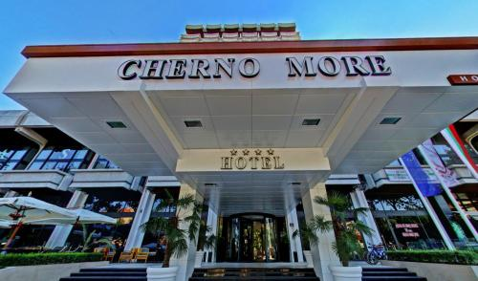 | Book here
Caprice | 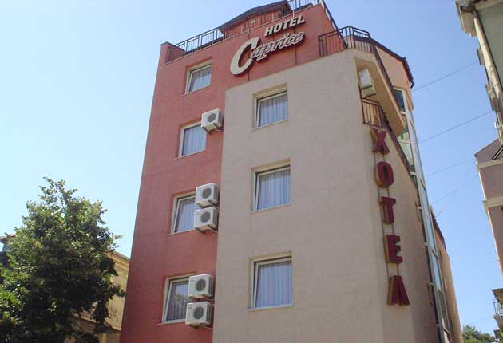 | Book here
Using the Promo code will give you a 12 % discount only in case of booking your stay at Rosslyn-Dimyat Hotel in the period 15 April – 26 September 2019.
Further remarks or questions
Please, fill in the registration form and send it to: soroptimistvarna@gmail.com
Registration deadline: 15 June 2019
Contact us:
DE | Bilyana Pavlova | +359 897 575851
EN | Maya Stefanova | +359 899 208683
BG | Lucy Dimitrova | +359 887 260783

LOOKING FORWARD TO SEEING YOU IN VARNA!
